8.36: a) The final speed of the bullet-block combination is
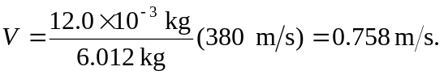Energy is conserved after the collision, so 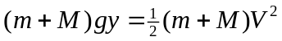, and
